{
"cells": [
{
"cell_type": "code",
"execution_count": 6,
"id": "5070196d",
"metadata": {},
"outputs": [
{
"name": "stdout",
"output_type": "stream",
"text": [
"Probability of selecting Box C given a Blue ball is drawn:\n",
"0.09523809523809525\n",
"\n",
"Rounded Probability: 0.0952\n"
]
}
],
"source": [
"P_A=1/4\n",
"P_B=1/2\n",
"P_C=1/4\n",
"\n",
"P_Blue_A=4/12\n",
"P_Blue_B=7/15\n",
"P_Blue_C=2/15\n",
"\n",
"P_Blue=(P_Blue_A*P_A)+(P_Blue_B*P_B)+(P_Blue_C*P_C)\n",
"P_C_given_Blue=(P_Blue_C*P_C)/P_Blue\n",
"\n",
"print(\"Probability of selecting Box C given a Blue ball is drawn:\")\n",
"print(P_C_given_Blue)\n",
"print(\"\\nRounded Probability:\",round(P_C_given_Blue,4))"
]
},
{
"cell_type": "code",
"execution_count": 7,
"id": "69d2448f",
"metadata": {},
"outputs": [
{
"name": "stdout",
"output_type": "stream",
"text": [
"Probability of selecting a Blue car: 0.3083\n",
"Probability that the car came from Section C given it is Blue: 0.1081\n"
]
}
],
"source": [
"P_A=1/4\n",
"P_B=1/2\n",
"P_C=1/4\n",
"\n",
"P_Blue_A=3/10\n",
"P_Blue_B=6/15\n",
"P_Blue_C=2/15\n",
"\n",
"P_Blue=(P_Blue_A*P_A)+(P_Blue_B*P_B)+(P_Blue_C*P_C)\n",
"P_C_given_Blue=(P_Blue_C*P_C)/P_Blue\n",
"\n",
"print(\"Probability of selecting a Blue car:\",round(P_Blue,4))\n",
"print(\"Probability that the car came from Section C given it is Blue:\",round(P_C_given_Blue,4))"
]
},
{
"cell_type": "code",
"execution_count": 8,
"id": "61c86f20",
"metadata": {},
"outputs": [
{
"name": "stdout",
"output_type": "stream",
"text": [
"TP: 210\n",
"TN: 190\n",
"FP: 30\n",
"FN: 150\n",
"Accuracy: 68.97 %\n",
"Precision: 87.5 %\n",
"Sensitivity: 58.33 %\n",
"Specificity: 86.36 %\n"
]
}
],
"source": [
"TP=210\n",
"TN=190\n",
"FP=30\n",
"\n",
"samples_per_class=1800\n",
"test_ratio=0.20\n",
"\n",
"test_samples=int((samples_per_class*2)*test_ratio)\n",
"positive_test=int(samples_per_class*test_ratio)\n",
"negative_test=int(samples_per_class*test_ratio)\n",
"\n",
"FN=positive_test-TP\n",
"\n",
"accuracy=(TP+TN)/(TP+TN+FP+FN)\n",
"precision=TP/(TP+FP)\n",
"recall=TP/(TP+FN)\n",
"specificity=TN/(TN+FP)\n",
"\n",
"print(\"TP:\",TP)\n",
"print(\"TN:\",TN)\n",
"print(\"FP:\",FP)\n",
"print(\"FN:\",FN)\n",
"print(\"Accuracy:\",round(accuracy*100,2),\"%\")\n",
"print(\"Precision:\",round(precision*100,2),\"%\")\n",
"print(\"Sensitivity:\",round(recall*100,2),\"%\")\n",
"print(\"Specificity:\",round(specificity*100,2),\"%\")"
]
},
{
"cell_type": "code",
"execution_count": 9,
"id": "81936e01",
"metadata": {},
"outputs": [
{
"data": {
"image/png":
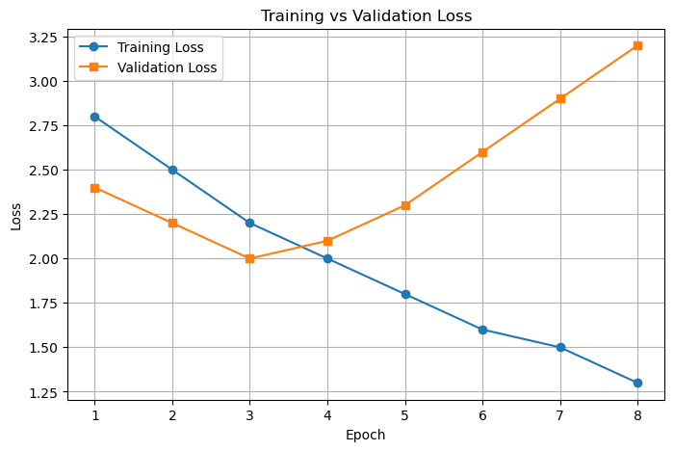,
"text/plain": [
"<Figure size 800x500 with 1 Axes>"
]
},
"metadata": {},
"output_type": "display_data"
},
{
"name": "stdout",
"output_type": "stream",
"text": [
"Overfitting begins at Epoch: 4\n"
]
}
],
"source": [
"import matplotlib.pyplot as plt\n",
"\n",
"epochs=[1,2,3,4,5,6,7,8]\n",
"training_loss=[2.8,2.5,2.2,2.0,1.8,1.6,1.5,1.3]\n",
"validation_loss=[2.4,2.2,2.0,2.1,2.3,2.6,2.9,3.2]\n",
"\n",
"overfit_epoch=None\n",
"\n",
"for i in range(1,len(epochs)):\n",
" if validation_loss[i]>validation_loss[i-1] and training_loss[i]<training_loss[i-1]:\n",
" overfit_epoch=epochs[i]\n",
" break\n",
"\n",
"plt.figure(figsize=(8,5))\n",
"plt.plot(epochs,training_loss,marker='o',label='Training Loss')\n",
"plt.plot(epochs,validation_loss,marker='s',label='Validation Loss')\n",
"plt.title(\"Training vs Validation Loss\")\n",
"plt.xlabel(\"Epoch\")\n",
"plt.ylabel(\"Loss\")\n",
"plt.xticks(epochs)\n",
"plt.grid(True)\n",
"plt.legend()\n",
"plt.show()\n",
"\n",
"print(\"Overfitting begins at Epoch:\",overfit_epoch)"
]
},
{
"cell_type": "code",
"execution_count": 10,
"id": "41349d6d",
"metadata": {},
"outputs": [
{
"data": {
"image/png":
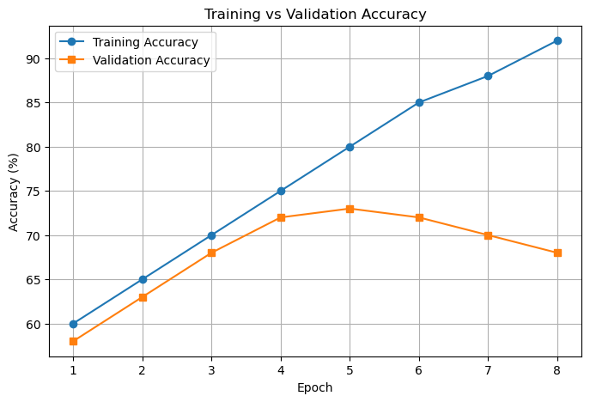,
"text/plain": [
"<Figure size 800x500 with 1 Axes>"
]
},
"metadata": {},
"output_type": "display_data"
},
{
"name": "stdout",
"output_type": "stream",
"text": [
"Overfitting begins at Epoch: 6\n"
]
}
],
"source": [
"import matplotlib.pyplot as plt\n",
"\n",
"epochs=[1,2,3,4,5,6,7,8]\n",
"training_accuracy=[60,65,70,75,80,85,88,92]\n",
"validation_accuracy=[58,63,68,72,73,72,70,68]\n",
"\n",
"overfit_epoch=None\n",
"\n",
"for i in range(1,len(epochs)):\n",
" if validation_accuracy[i]<validation_accuracy[i-1] and training_accuracy[i]>training_accuracy[i-1]:\n",
" overfit_epoch=epochs[i]\n",
" break\n",
"\n",
"plt.figure(figsize=(8,5))\n",
"plt.plot(epochs,training_accuracy,marker='o',label='Training Accuracy')\n",
"plt.plot(epochs,validation_accuracy,marker='s',label='Validation Accuracy')\n",
"plt.title(\"Training vs Validation Accuracy\")\n",
"plt.xlabel(\"Epoch\")\n",
"plt.ylabel(\"Accuracy (%)\")\n",
"plt.xticks(epochs)\n",
"plt.grid(True)\n",
"plt.legend()\n",
"plt.show()\n",
"\n",
"print(\"Overfitting begins at Epoch:\",overfit_epoch)"
]
},
{
"cell_type": "code",
"execution_count": null,
"id": "7620c8bf",
"metadata": {},
"outputs": [],
"source": []
}
],
"metadata": {
"kernelspec": {
"display_name": "Python 3 (ipykernel)",
"language": "python",
"name": "python3"
},
"language_info": {
"codemirror_mode": {
"name": "ipython",
"version": 3
},
"file_extension": ".py",
"mimetype": "text/x-python",
"name": "python",
"nbconvert_exporter": "python",
"pygments_lexer": "ipython3",
"version": "3.10.9"
}
},
"nbformat": 4,
"nbformat_minor": 5
}

